**Database**

This is a MongoDB Compass view showing an admin user's document from the jak-attendance database.

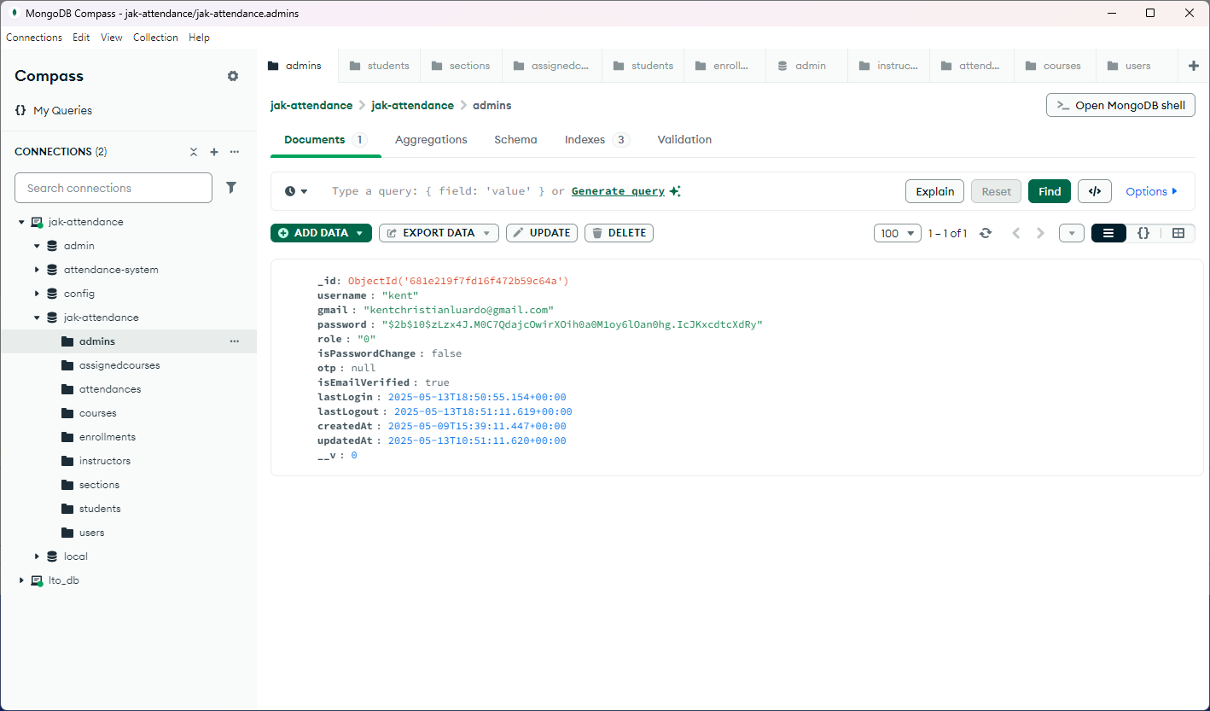

**Login Failed**

The login form shows an "Invalid gmail or password" error, meaning the credentials entered don’t match the records.

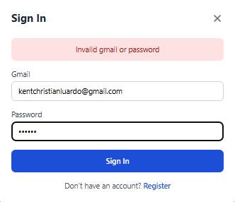

**Database**

This is a MongoDB Compass view of the jak-attendance database, showing a document from the admins

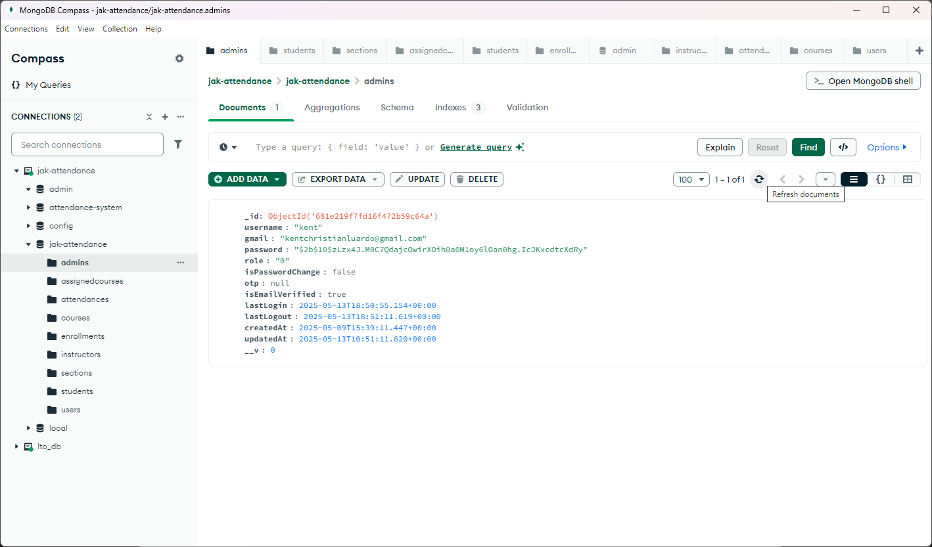**Login Successfully**

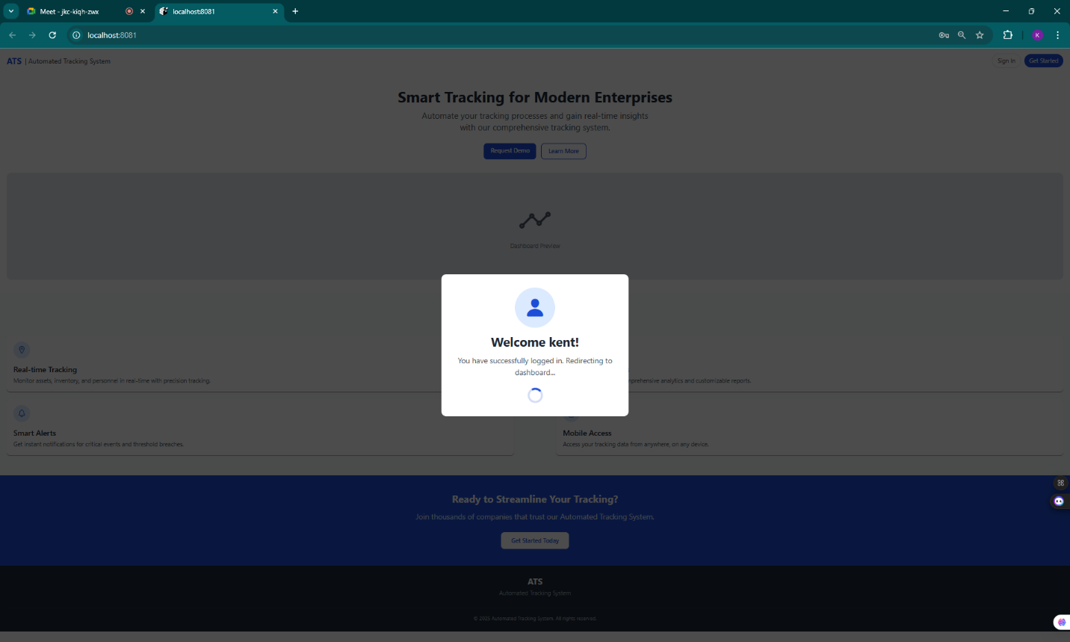

**Database - lastLogin**

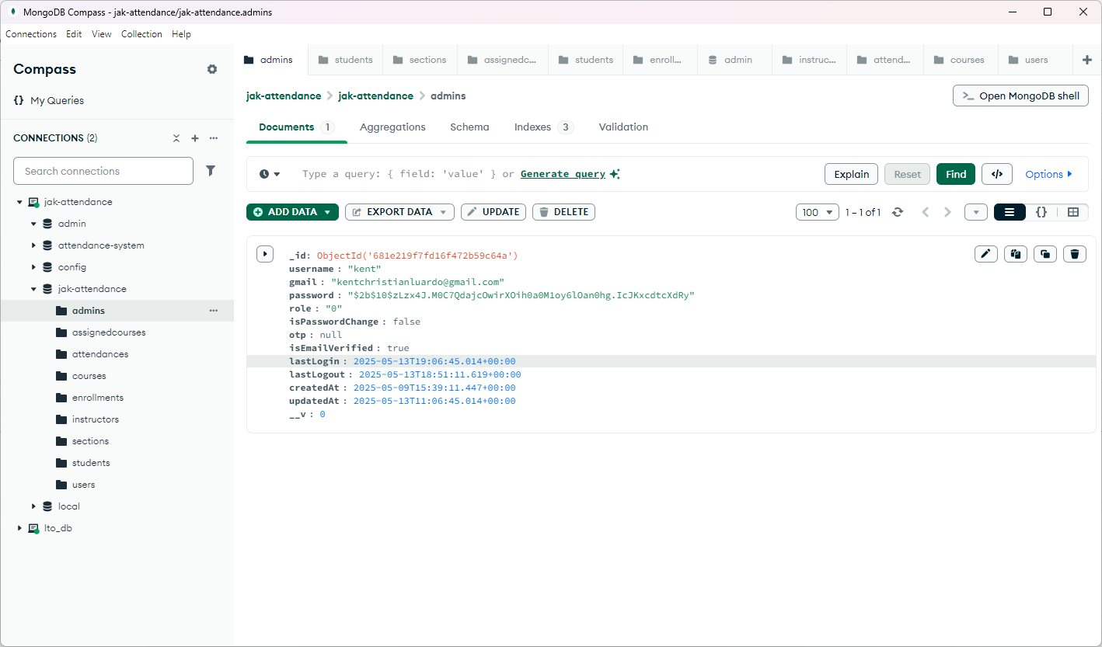

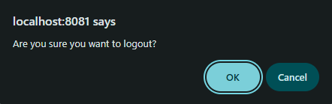  
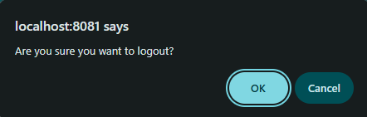**Logout Successfully**

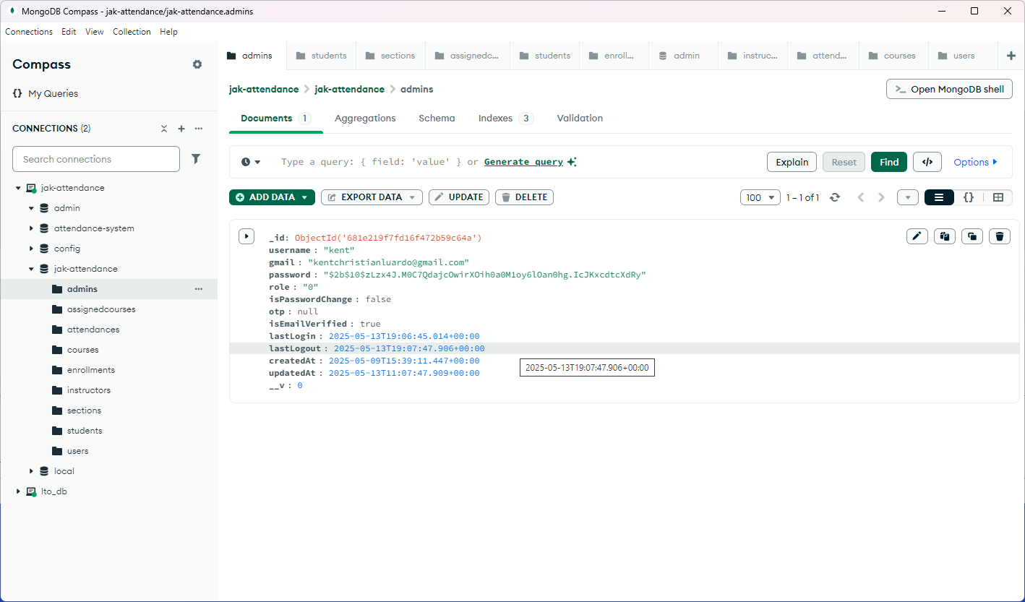**Database - lastLogout**